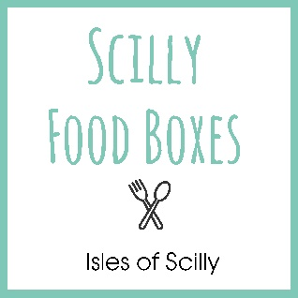

General Guidelines for Observing COVID-19 Restrictions when ordering and receiving deliveries from Scilly Food Boxes

We have a role to play in adhering to the Government Guidelines and therefore ask that you observe the following:
- Please let us know prior to your delivery if you are experiencing any symptoms of COVID-19 or are self-isolating.

- We operate a cashless system. All payments will need to be made online at the time of ordering or via BACS by arrangement.

- We will not be able to enter the property prior to your arrival and put away your order at this time. Please inform us of your arrival time and we will aim to deliver your order once you have arrived at the property.

- There will be no physical handing over of food. We will ring the doorbell, leave your delivery on the doorstep and step 2 meters back.

- If you are out, your order will be left outside the property and we will aim to contact you to let you know its there.

- Any orders that require two people will be delivered by persons living within the same household.

